

Salesforce Example Content

How to enable security keys for your company's Salesforce account
This guide will run you through the process of how to enable users to use a security key as a MFA option.

Add Title
  Click the gear    Click Setup   |  | 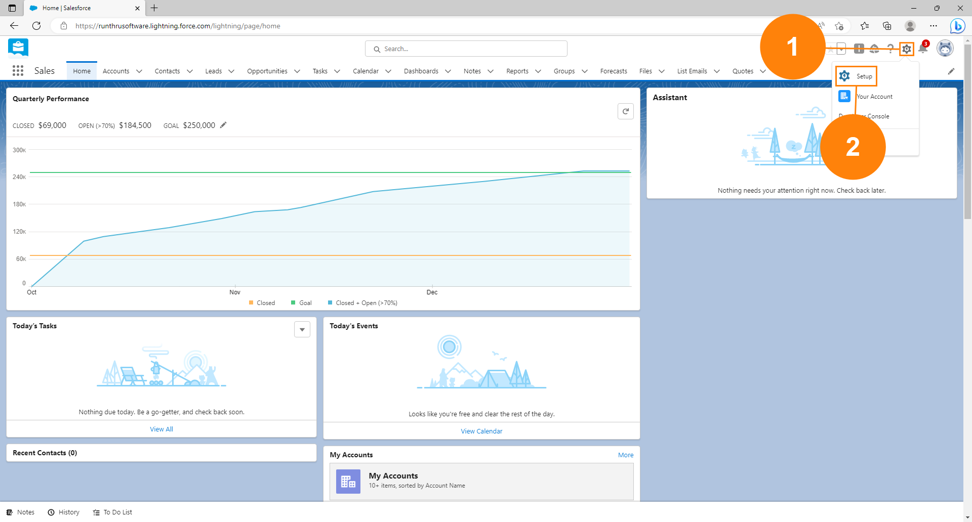

Add Title
  Search for Identity Verification.    Click Identity Verification |  | 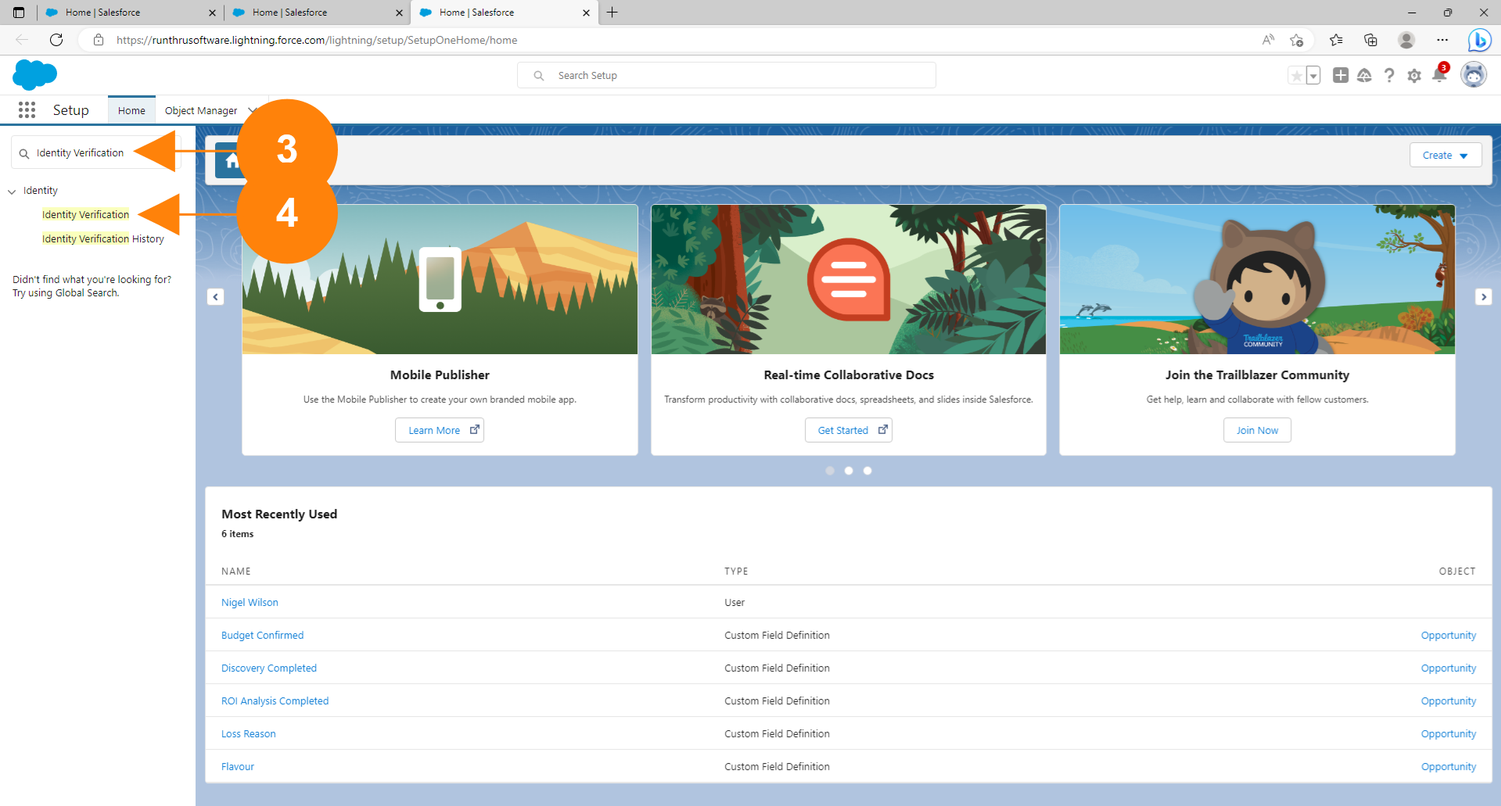

Add Title
  Check let users verify their identity... as shown. |  | 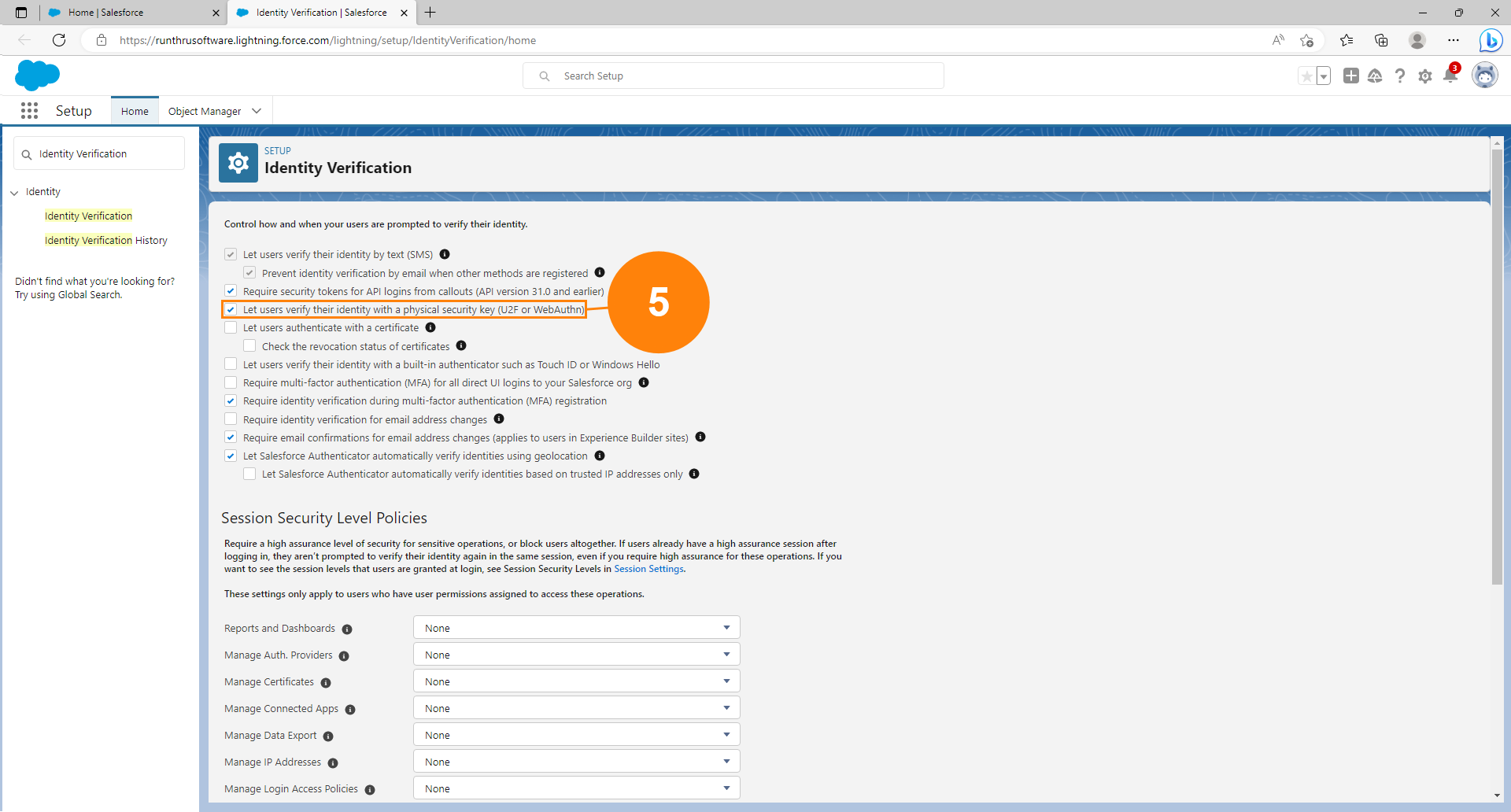

Add Title
  Scroll to the bottom of the page and click Save. |  | 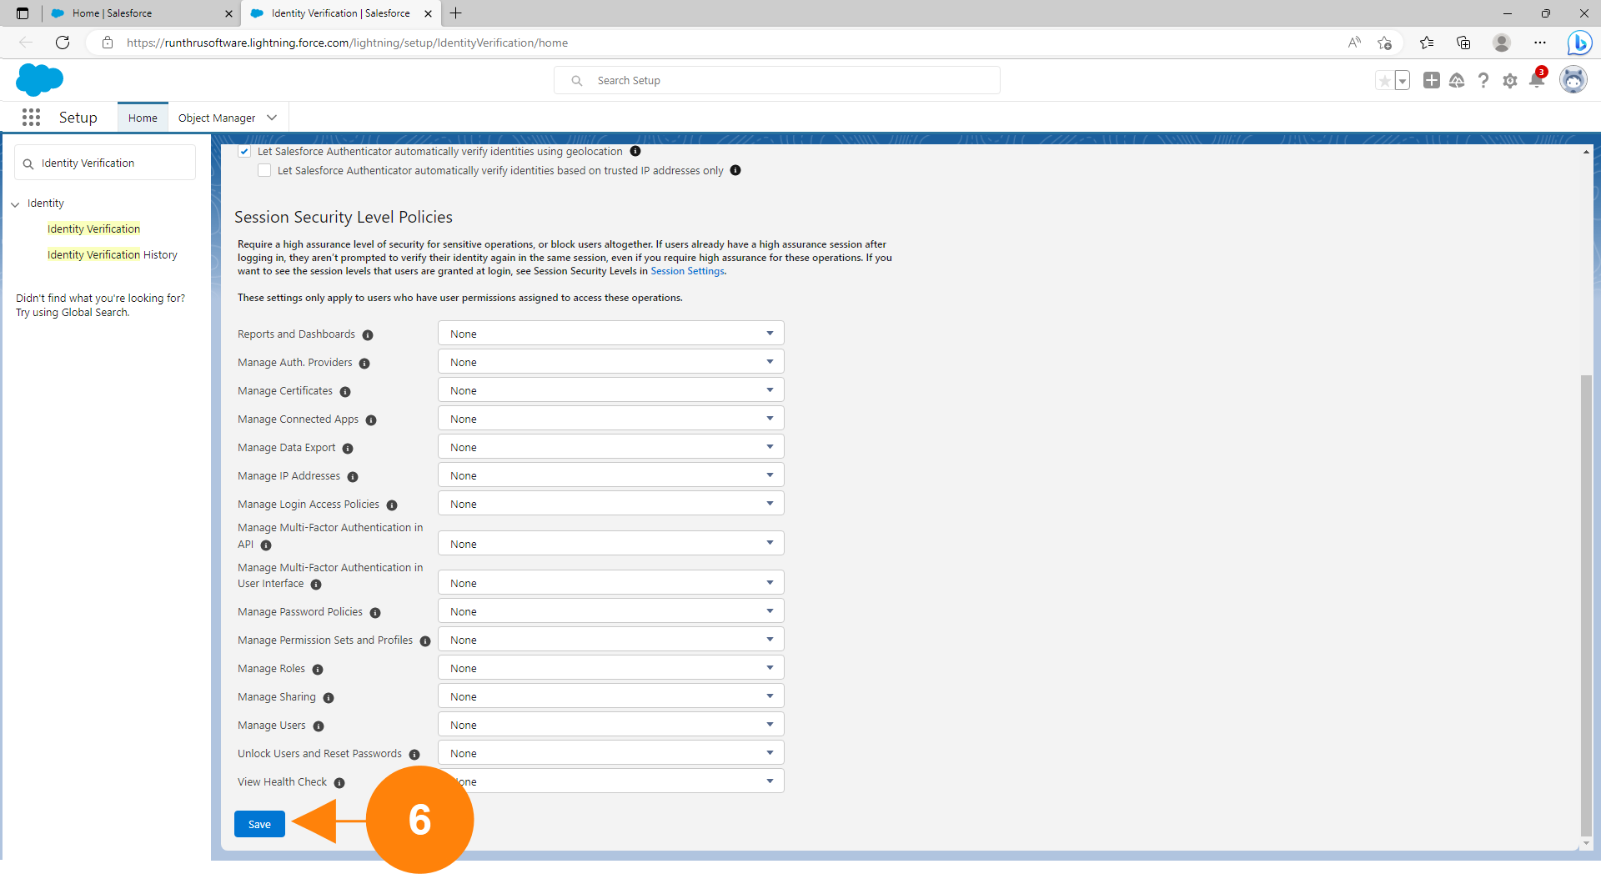

Add Title
  You should see a notification popup telling you that the setting has been saved |  | 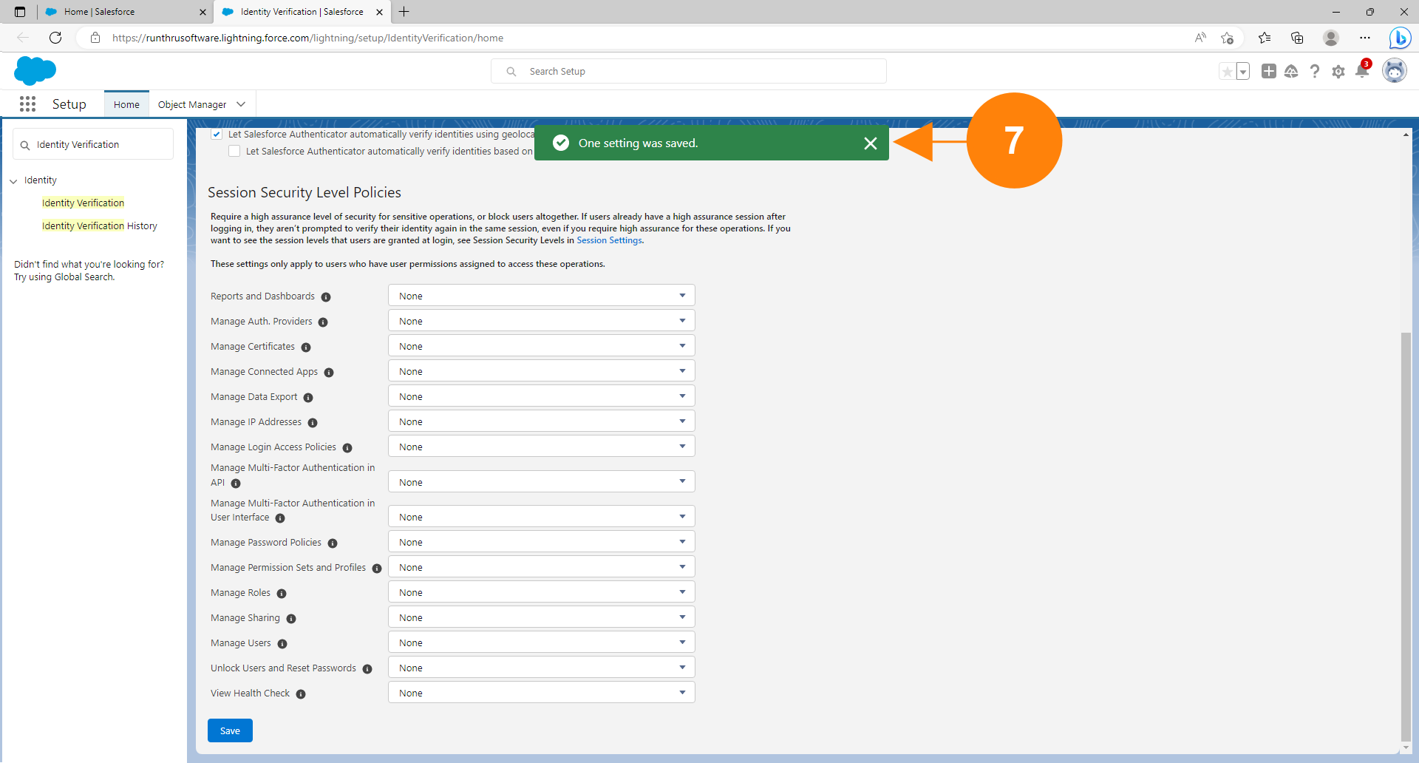

You're done!
Congratulations, you've reached the end of the guide.
Users can now register and use security keys as a 2nd factor of authentication when signing into Salesforce

